**Project Description**

This project is a comprehensive toolset designed to help industry analysts, AI strategists, and solution architects generate actionable proposals for the adoption of AI and Generative AI (GenAI) solutions in various industries and companies. By integrating advanced research, use case analysis, dataset discovery, and GenAI solutions, the project automates the entire process of crafting solutions that enhance operations, improve customer experience, and drive technological innovation.

The project consists of four main components:

1. **Agents**: These are specialized AI-driven entities responsible for specific tasks, such as researching industry trends, proposing AI use cases, and recommending GenAI solutions.
2. **Tasks**: Each task is an action that the system performs. Tasks are tied to the agents and executed sequentially to generate insights and solutions for a given company.
3. **Tools**: These are external resources that the agents use to gather information. The tools include web search tools, datasets, AI/ML resources, and more.
4. **Execution Framework**: The Crew framework orchestrates the agents and tasks, executing them in a predefined sequence to deliver the final result.

System Components

**1. Agents**

The following agents are used in the system to handle various research and solution generation tasks:

**Industry Researcher Agent**

* **Role**: Industry Analyst
* **Goal**: Identify key trends, challenges, and strategic goals in a specific company or industry.
* **Description**: This agent specializes in gathering insights about industries and companies, analyzing their offerings, challenges, and competitors. It leverages a tool to perform in-depth industry research using web search.

**Use Case Generator Agent**

* **Role**: AI Strategist
* **Goal**: Propose actionable AI/GenAI use cases to improve operations and customer satisfaction.
* **Description**: This agent analyzes market standards and industry trends to generate AI/GenAI use cases that could drive innovation and operational excellence for the target company.

**Resource Collector Agent**

* **Role**: Data and Resource Specialist
* **Goal**: Locate relevant datasets, tools, and APIs to support proposed AI/GenAI use cases.
* **Description**: This agent searches for datasets, tools, and APIs from various platforms such as Kaggle, HuggingFace, and GitHub. It ensures that the proposed AI solutions are supported by the necessary data and tools.

**GenAI Solution Recommender Agent**

* **Role**: Generative AI Innovator
* **Goal**: Suggest cutting-edge GenAI solutions for document search, automated reporting, and customer engagement.
* **Description**: This agent proposes advanced GenAI solutions that leverage the latest technologies in AI, particularly in document processing, reporting automation, and customer engagement systems.

**2. Tasks**

Each agent executes a specific task, which contributes to the overall research and solution proposal. The tasks are defined as follows:

**Industry Researcher Task**

* **Description**: Perform detailed research on a given industry or company. Identify key trends, challenges, and strategic goals, along with analyzing competitors and their use of AI/ML technologies.
* **Expected Output**: A comprehensive report that includes industry trends, company challenges, and competitor analysis.

**Use Case Generator Task**

* **Description**: Based on the industry research, generate actionable AI/GenAI use cases for the target company. These use cases focus on improving operations, customer experience, and efficiency.
* **Expected Output**: A prioritized list of actionable AI/GenAI use cases, including descriptions, impacts, and feasibility analysis.

**Dataset Search Task**

* **Description**: Locate relevant datasets, tools, and APIs that can support the proposed AI/GenAI use cases.
* **Expected Output**: A collection of datasets and tools with descriptions, sources, and suggested usage for the proposed use cases.

**GenAI Solution Task**

* **Description**: Propose cutting-edge GenAI solutions tailored to the given company or industry, focusing on document search, reporting automation, and AI-powered customer interaction systems.
* **Expected Output**: A detailed proposal of GenAI solutions, including descriptions, use cases, feasibility, and recommended tools and frameworks.

**3. Tools**

The following tools are integrated into the system to help agents gather data and perform analyses:

**Industry Research Tool**

* **Description**: This tool performs web searches to gather detailed insights about industries and companies, helping the Industry Researcher Agent understand the market trends and challenges.

**Use Case Analysis Tool**

* **Description**: This tool searches for market standards and AI/ML use cases in specific industries, enabling the Use Case Generator Agent to propose relevant and impactful use cases.

**Dataset Search Tool**

* **Description**: This tool searches for datasets, APIs, and other resources from platforms like Kaggle, HuggingFace, and GitHub. It supports the Resource Collector Agent in gathering the necessary resources for AI/GenAI use cases.

**GenAI Solution Tool**

* **Description**: This tool searches for advanced generative AI solutions, including technologies for document processing, reporting automation, and customer interaction systems, helping the GenAI Recommender Agent propose innovative solutions.

**4. Execution Framework**

The **Crew** framework orchestrates the entire process. It manages the interaction between agents and tasks, handles input/output flow, and ensures that the tasks are executed sequentially to generate a comprehensive proposal.

* **Crew Class**: This class is responsible for initializing the agents, tasks, and the process flow.
* **Process**: Defines how tasks should be executed. In this case, the process is **sequential**, meaning that tasks are performed one after the other.
* **Input/Output**: The input is provided in the form of company information (e.g., company name), and the output is a detailed GenAI solutions proposal saved as a markdown file.

**Architecture flowchart**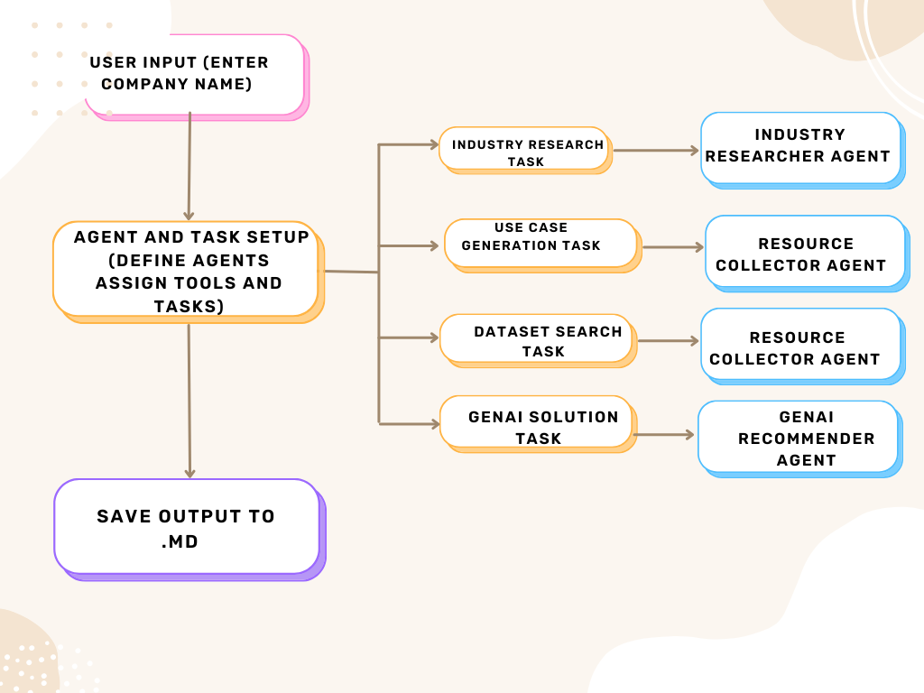

**Environment Setup**

To run the project, ensure you have the following:

1. **Python** (preferably 3.7 or higher)
2. Install the required dependencies:
3. pip install -r requirements.txt
4. Set up **environment variables**:
   * GOOGLE_API_KEY: API key for Google's Gemini model.
   * SERPER_API_KEY: API key for Serper search tool.
5. **Run the project**: You can start the system by running the crew_module.py script. This will initialize the agents, run the tasks sequentially, and generate the proposal file.

**Sample Output**

After running the system, the output file genai_solutions_proposal.md will contain:

1. **Industry Trends and Insights**: Key trends, challenges, and strategic goals in the industry.
2. **AI/GenAI Use Cases**: A prioritized list of actionable AI/GenAI use cases.
3. **Datasets and Tools**: Relevant datasets and tools for the proposed use cases.
4. **GenAI Solutions**: Detailed proposals for GenAI-driven solutions, including descriptions and feasibility analysis.

**Conclusion**

This system leverages the power of AI agents and generative models to provide comprehensive and actionable insights for businesses looking to adopt AI/GenAI solutions. By automating the research and solution proposal generation process, CrewAI helps companies stay ahead of industry trends and implement cutting-edge AI technologies.